DESCRIPTION
These MonitorSet and the Agent procedure are created to monitor the KLC/KRC activity on an endpoint. If KRC/KLC of an
endpoint is taken, it lets the users know that their machine is being remoted for a while and asks if this needs to be
terminated. If the user answers a ‘YES’, KRC/KLC session gets terminated. If the user answers with a ‘NO’, KLC/KRC session gets continued as usual.

Install instructions
1. Extract the files from the attached zip file.
2. Import the procedure XML into the agent procedure module: https://helpdesk.kaseya.com/hc/en-gb/articles/229012068.
3. Import the monitorset XML to the Monitor module.
4. Assign the monitorset to desired machines by selecting the Agent procedure as below:
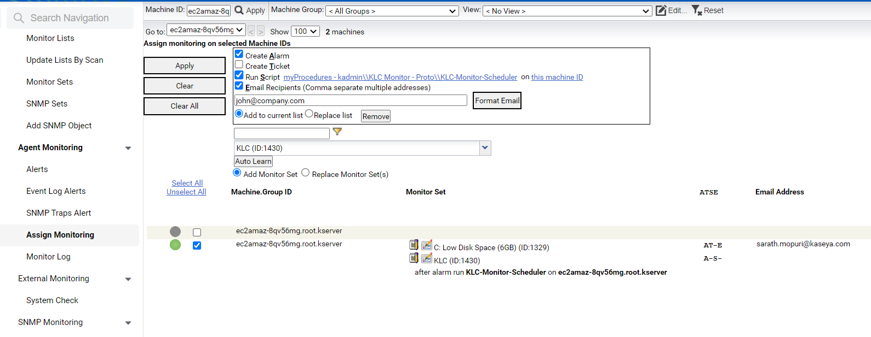

(Email recipients and other action items are optional)

